FilterFPS

Description

FilterFPS Shell script provides a simple menu-driven interface to perform various tasks related to file operations and process management. Users can choose to display file properties, search for processes by keyword, list processes based on different criteria, or exit the script.

Usage

* Make the script executable: chmod +x FilterFPS.sh
* Run the script: ./FilterFPS.sh

Menu Options

1. Display file properties and save to file:

* Prompts the user for a file name and displays its properties, saving the output to file_properties.txt.

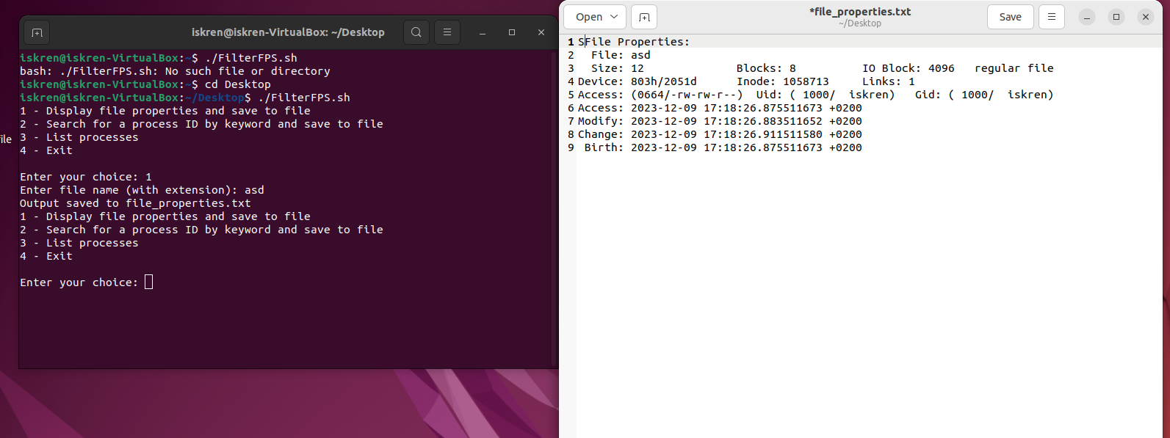

* If the user enters invalid file name, the script outputs to the console : “Error: File '*The file name*' does not exist.

”

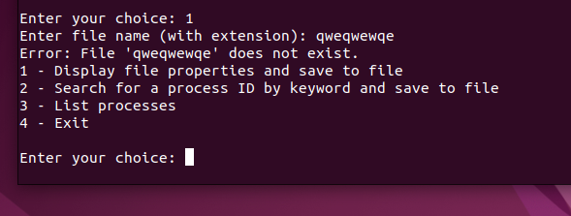

1. Search for a process ID by keyword and save to file

* Prompts the user for a keyword, searches for processes containing the keyword, and saves the output to process_search.txt.

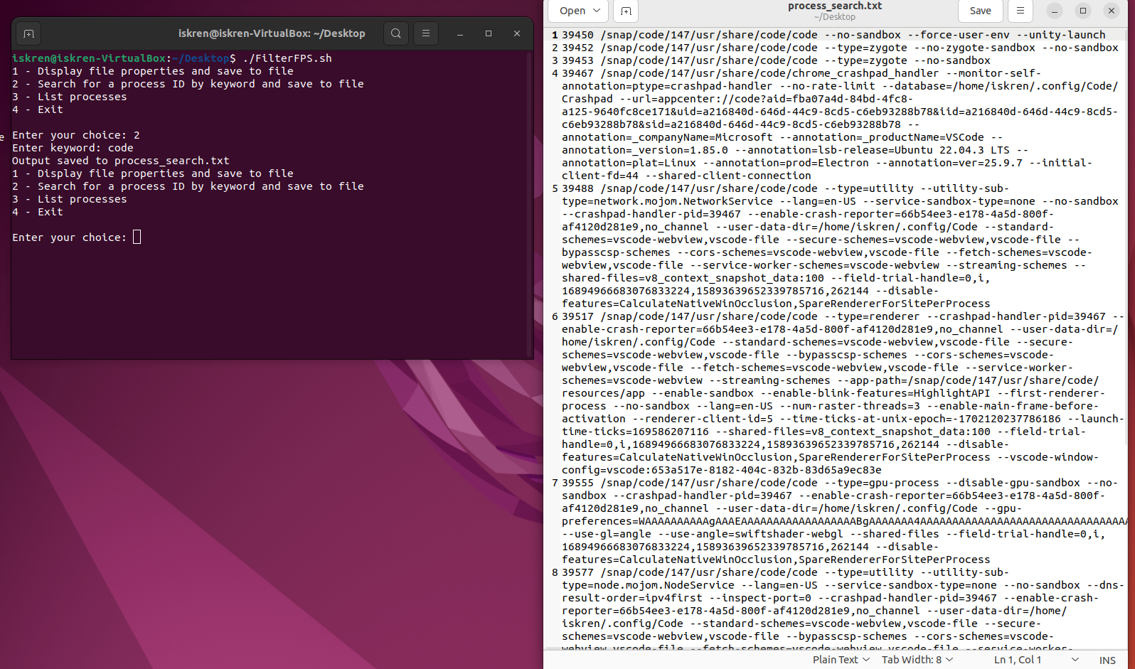

* If the user enters a keyword that does not match with any processes, the script outputs in the console:

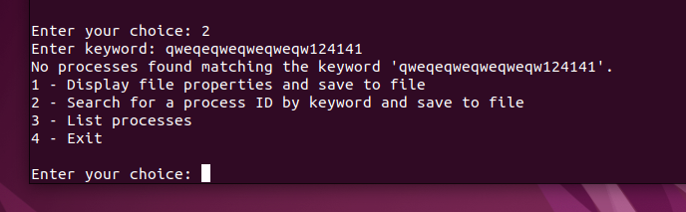

3. List processes

- Provides sub-options to list processes by:

a) Process ID

b) Process name

c) Parent process name

d) Execution time

Filtering by process ID

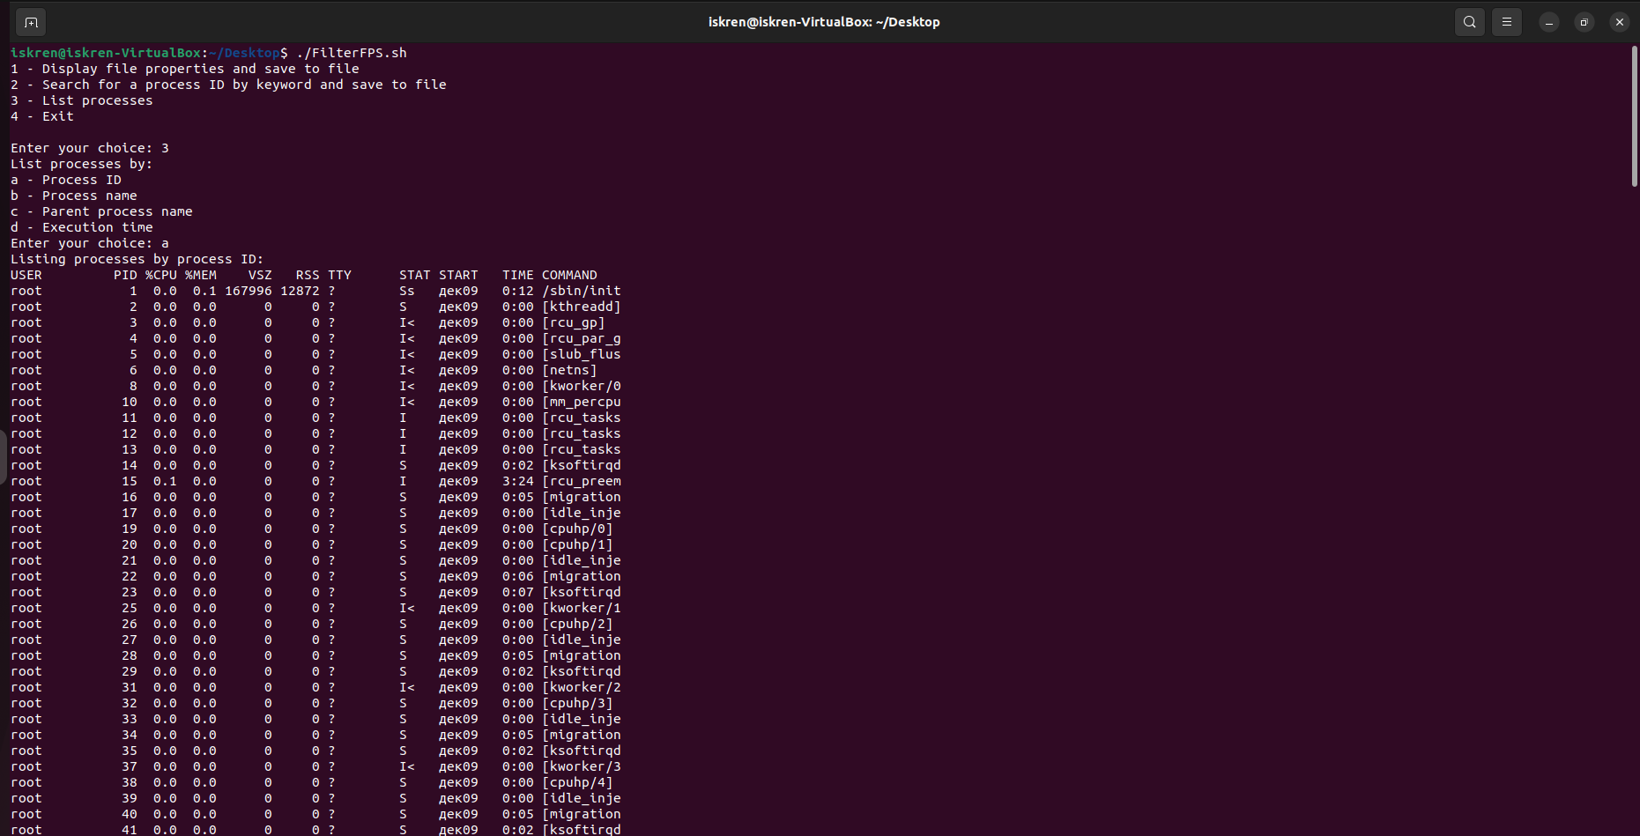

Filtering by process name

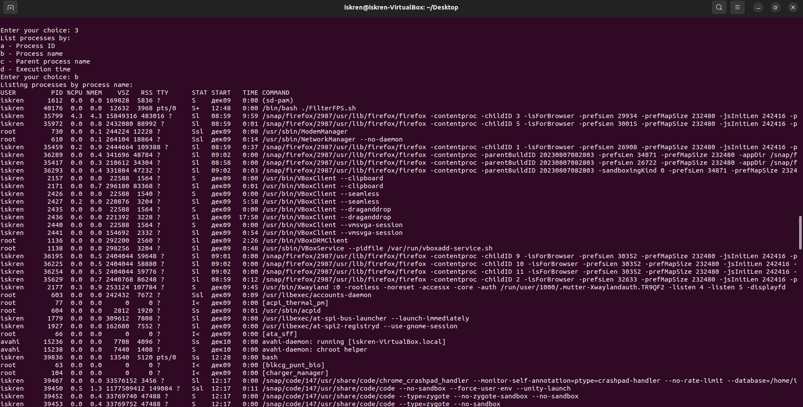

Filtering by parent process name

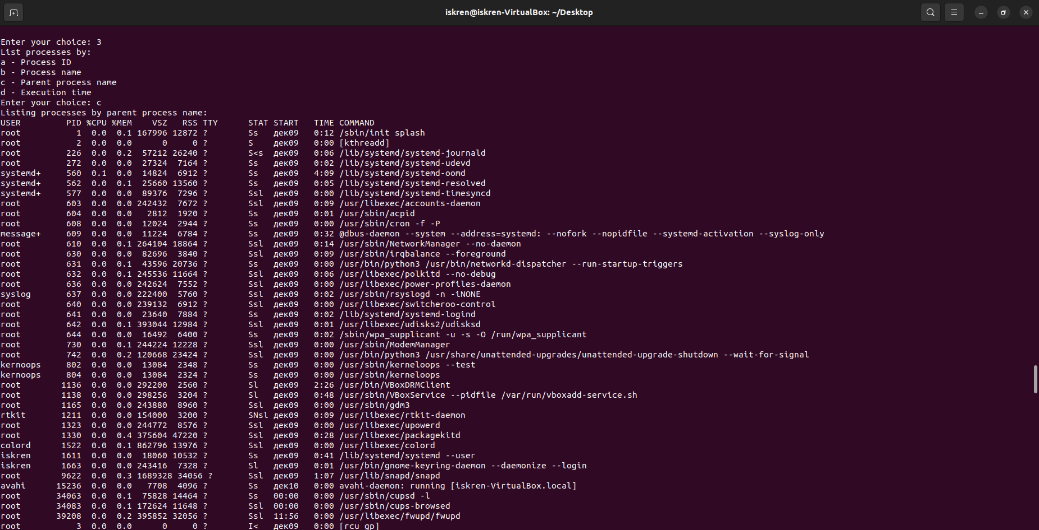

Filtering by execution time

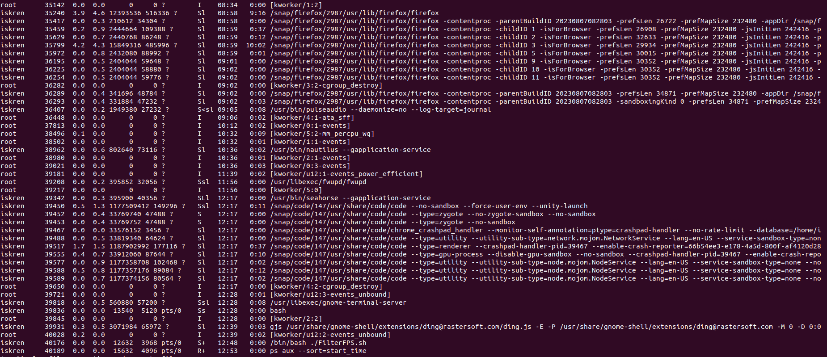

* If the user enters invalid input he gets error message: “Invalid sub-choice for listing processes”



1. Exit

* Exits the script.

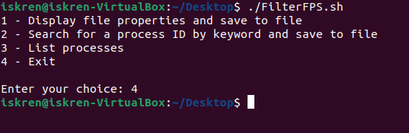

File output

* file_properties.txt: Contains the properties of the specified file.
* process_search.txt: Contains the process IDs and command lines of processes matching the provided keyword.

Notes

* The script works only on Linux
* Ensure the script has execution permissions before running (chmod +x FilterFPS.sh).
* The script includes error handling for non-existent files and notifies if no processes match the provided keyword.

Sources

* <https://www.howtoforge.com/tutorial/linux-grep-command/>
* <https://man7.org/linux/man-pages/man1/pgrep.1.html>
* <https://ryanstutorials.net/linuxtutorial/piping.php>